M.Saad Coal S2025332011
Section A: Segmented Memory and System Organization
1. The Concept of Segmented Memory Architecture
When we talk about segmented memory architecture, we are basically looking at a way processors break down the computer's physical RAM into smaller, variable-length chunks called segments. Instead of treating memory as one giant, continuous linear track of bytes starting from zero and going all the way up to the hardware limit, the CPU views it as a collection of separate functional compartments. Each compartment handles a specific aspect of a program, like its instructions, variables, or runtime stack.
The engineering shift away from a single continuous memory space happened for a few very practical reasons:
- Breaking the 16-bit register barrier: In early processors like the Intel 8086, internal registers were strictly 16 bits wide, meaning they could only index up to 64 KB of data on their own. By introducing segmentation, the hardware could take a 16-bit segment value, shift it, and add a 16-bit offset to it, creating a 20-bit physical address. This allowed the system to address up to 1 MB of RAM without forcing engineers to build wider, more expensive 32-bit registers at the time.
- Aligning with how code is actually structured: Programs don’t compile as a uniform blob. Software naturally splits into blocks: instructions that shouldn't change, global variables, and temporary local data. Segmentation gives the hardware a way to mirror this logical layout, making it much cleaner for compilers to organize code.
- Enabling easy program relocation: If you hardcode a program into a continuous memory track, it has to look for variables at exact, permanent physical spots. With segmentation, a program becomes completely portable. The operating system can slide the program anywhere in physical RAM just by altering the baseline values in the segment registers, while the internal offsets inside the program code remain completely unchanged.
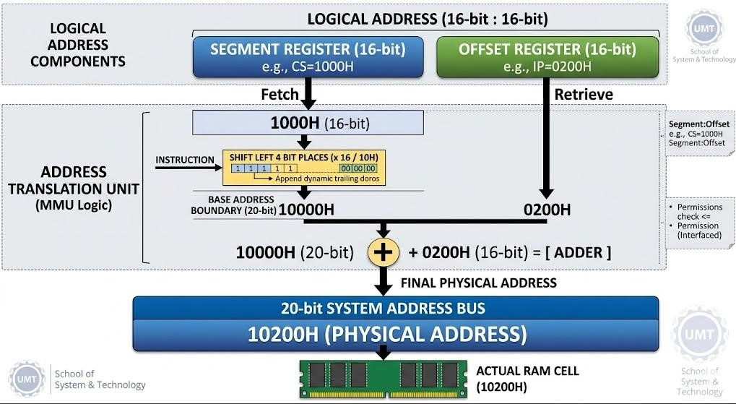
2. Role and Function of Memory Segments during Execution
During runtime, the processor tracks and manages the execution environment using four primary hardware segments, each allocated its own unique job:
- Code Segment (CS): This is where the actual executable machine instructions live. The CPU’s Instruction Pointer (IP) points directly into this zone to fetch the next instruction byte. To keep the system stable and prevent major bugs, the hardware marks this segment as read-only, which stops running programs from accidentally modifying or wiping out their own code.
- Data Segment (DS): This segment acts as the default home for global and static variables that are initialized when the program first loads. Whenever an assembly instruction looks up a variable name or memory reference without specifying a special override, the CPU automatically looks inside the boundaries defined by the DS register.
This segment has to be read/write enabled so values can be updated.
- Stack Segment (SS): The stack segment handles the dynamic execution workflow of the program. It manages a Last-In, First-Out (LIFO) memory structure that stores critical runtime data like function return addresses, parameters passed during subroutine calls, and local variables used inside active blocks.
- Extra Segment (ES): This is essentially an extra data scratchpad used by the CPU for intensive data-handling operations, particularly string manipulations or array copies. When copying large chunks of data, the program can keep its source pointer in the standard Data Segment (DS) and point its destination to the Extra Segment (ES), avoiding the slow overhead of constantly swapping a single data register back and forth.
3. Advantages and Disadvantages of Segmented Memory
Like all architectural solutions, segmentation presents an engineered trade-off between conceptual elegance and physical hardware constraints.
On the positive side (Advantages):
- It provides clear logical modularity. Different modules can be compiled and mapped into their own distinct segments, meaning variables, code, and stacks don’t bleed into one another.
- It enables granular security permissions. You can set a code segment to execute-only, lock data segments from running code, and configure stacks to prevent code execution entirely, which stops classic buffer overflow hacks in their tracks.
- It allows for code sharing. If you run three instances of the same application, the operating system can point all three Code Segment registers to the exact same physical memory block, saving massive amounts of RAM while keeping their data and stack segments completely isolated.
On the negative side (Disadvantages):
- External Fragmentation is a major issue: Because segments dynamically adjust to whatever size a program needs, loading and closing applications leaves mismatched, random gaps of free space scattered across RAM. Over time, the OS has to run heavy, slow compaction routines to clean up and group these gaps.
- Address calculation latency: Every single time the CPU fetches data, it has to do a bitshift and addition math problem to translate the logical address into a physical one, which requires dedicated, complex hardware circuits inside the Memory Management Unit (MMU).
- Obsolescence in modern hardware: Modern 32-bit and 64-bit processors use a "flat memory model" combined with Paging (breaking memory into uniform 4 KB blocks). Paging completely eliminates external fragmentation. Today, modern operating systems mostly bypass classic hardware segmentation by zeroing out the segment bases and relying entirely on paging for memory isolation.
4. Memory Protection and Program Modularity
In a multitasking or multiprogramming system where dozens of apps are crammed into RAM at the same time, segmentation acts as a strict physical firewall.
From a protection standpoint, every segment descriptor contains a specific "limit" value that defines exactly how large that segment is. Every time an app tries to access memory, the MMU runs an automatic hardware check:
MMU Hardware Verification Rule:
Is the requested Address Offset <= Segment Limit?
Are the access rights authorized (e.g., trying to write to a read-only Code Segment)?
If a violation occurs, the processor triggers a Segmentation Fault exception and kills the process.
From a modularity standpoint, segmentation lets software modules grow or shrink dynamically in real-time. For instance, if a recursive function causes the execution stack to grow rapidly, it can expand safely within its own segment limit without running the risk of bleeding into and overwriting static variables sitting in the adjacent data segment.

Section B: Segment Registers and Memory Access
1. Purpose of Segment Registers (CS, DS, SS, ES)
Segment registers are specialized, high-speed 16-bit storage registers inside the CPU. They don't store actual data or instructions; instead, their sole purpose is to act as pointer selectors that hold the baseline starting addresses of the active memory segments currently in use.
- CS (Code Segment): Tracks the base of the code environment where execution instructions are stored.
- DS (Data Segment): Points to the base of the region where global and static variables are kept.
- SS (Stack Segment): Establishes the starting base of the runtime stack execution pool.
- ES (Extra Segment): Holds an auxiliary data base address for large string and block memory operations.
2. Interaction Between Segment Registers and Offset Registers
A segment register on its own cannot pinpoint a specific variable or command because it only marks the very beginning boundary of a massive memory block. To find a precise byte, the segment register must be paired with an offset register, which tracks exactly how far down to go from that segment's starting line. The CPU matches these up using strict default register pairs:
- CS : IP → The Code Segment register always pairs with the Instruction Pointer to fetch and execute successive code commands.
- DS : SI / DI / BX → The Data Segment register works alongside index registers like the Source Index or Destination Index to navigate through arrays or structured data blocks.
- SS : SP / BP → The Stack Segment register pairs with the Stack Pointer (to find the active top of the stack) and the Base Pointer (to locate variables inside a specific function call frame).
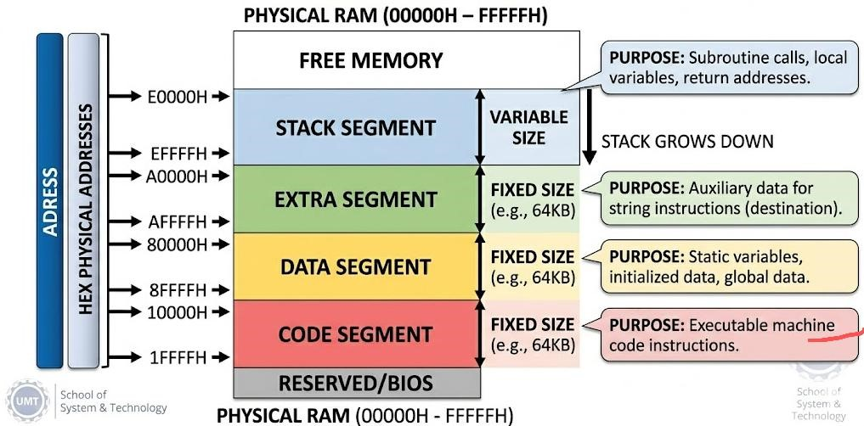
3. Why Segment Registers Are Vital in Low-Level Programming
Without segment registers, a processor with a 16-bit architecture would be completely blind to anything beyond 64 KB of RAM. Segment registers essentially give the CPU a sliding window that can move across a much larger physical memory space. They allow low-level assembly code to be written using clean, predictable relative offsets rather than permanent, absolute physical locations. This makes compiled programs highly flexible, leaving the job of assigning final physical locations to the operating system at runtime.

Section C: Offset Registers and Execution Flow
1. The Instruction Pointer (IP) and the Code Segment
The Instruction Pointer (IP) is an offset register that continuously tracks the relative distance of the next machine instruction scheduled for execution within the current Code Segment. The CPU relies on the logical pair CS:IP to find the exact memory spot to read. Every time an instruction is fetched, the control unit automatically updates the IP so it points to the next sequential command byte. When your code performs a branch, loop, or function call (like a JMP or CALL), the CPU modifies the IP value directly, altering the path of execution.
2. The Stack Pointer (SP) and Subroutine Management
The Stack Pointer (SP) is an offset register that is dedicated to tracking the absolute top of the Stack Segment (SS:SP). It is vital for handling function calls safely:
- When a program executes a CALL instruction, the CPU automatically pushes the current address inside the Instruction Pointer (the return address) onto the stack, and the SP shifts downward to secure that spot.
- While the function runs, the stack can expand further to hold local parameters and variables.
- When the function hits a RET (Return) instruction, the processor pops that saved address back off the stack and drops it right back into the IP register, allowing execution to resume exactly where it left off.
3. How BP, SI, and DI Support Operations
- Base Pointer (BP): While the Stack Pointer (SP) shifts constantly as data moves on and off the stack, the BP register is used to lock onto a fixed anchor point inside a function's stack frame. This gives the program a stable reference point to locate parameters and local variables using simple, unchanging offsets (like [BP+4] or [BP-2]), no matter how much the SP fluctuates.
- Source Index (SI): This register acts as an offset pointer used to read data bytes sequentially from a source string or array located within the Data Segment.
- Destination Index (DI): This register acts as the offset pointer used to write the processed bytes into a destination string or array, typically mapped inside the Extra Segment (ES).
4. Why Offset Registers Are Necessary
A memory segment can span up to 64 KB of space. If a processor relied purely on segment registers, it could only ever point to the very first byte (offset 0) of each segment block. Offset registers are essential because they provide the fine-grained coordinates needed to navigate inside a segment, letting the processor access any specific byte within that block.

Section D: Logical and Physical Addressing
1. Differences with Examples
Logical Address: This is the virtual coordinate that the compiler generates and the programmer sees while writing code. It is written in the notation Segment:Offset (e.g., 2000H:0400H).
Physical Address: This is the final, concrete 20-bit or 32-bit binary number sent across the physical wires of the motherboard's address bus to activate a specific storage slot inside the actual RAM chips.
Example: If an assembly program references a logical address of 1000H:0200H, the programmer sees it as offset 0200H inside segment 1000H. When the hardware translates this, it multiplies the segment by 16 (10000H) and adds the offset (0200H), placing a final physical address of 10200H onto the system bus.
2. Why Modern Systems Prefer Logical Addressing
Forcing software to use direct physical addresses causes severe problems in modern computing:
- Multitasking fails completely: If two different applications are hardcoded to write data to physical address 00500H, they cannot run at the same time without overwriting each other's data and crashing the system.
- Zero security separation: If programs have direct physical access, any app can read or modify the operating system kernel or access private data from neighboring programs.
Logical addressing introduces a clean layer of abstraction. Every app runs in its own isolated logical window, leaving the operating system entirely free to safely manage where that data actually sits in physical RAM.
3. Mapping Multiple Logical Addresses to a Single Physical Address
Because memory segments can overlap, different Segment:Offset combinations can translate to the exact same physical storage cell. This is known as memory aliasing.
Overlapping Segments Proof:
Case A: Logical Address = 1000H : 0200H → (1000H * 10H) + 0200H = 10200H
Case B: Logical Address = 1020H : 0000H → (1020H * 10H) + 0000H = 10200H
Even though the program views these as two completely different coordinates, they map directly to the identical physical RAM slot (10200H).
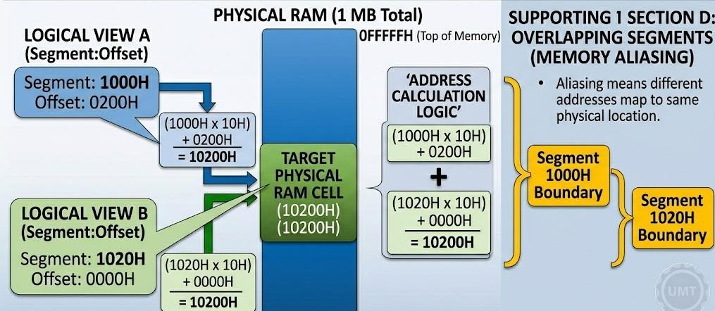
4. Consequences of Incorrect Address Translation
If the translation logic or registers break down, the results are catastrophic for the system:
- Kernel Panics and Crashes: An application might accidentally write data directly into a memory region owned by the operating system kernel, causing an immediate system crash or blue screen.
- Security Exploits: Isolation barriers fail, meaning a regular application could read private data blocks (like passwords or encryption keys) from neighboring apps.
- Silent Data Corruption: Variables or files loaded in memory can be silently overwritten by misdirected write instructions, destroying data integrity without throwing an obvious error.

Section E: Address Conversion and Assembly Language Concepts
1. The Step-by-Step Conversion Process
To convert a logical Segment:Offset address into a 20-bit physical address, the processor's internal hardware performs a quick four-step math routine:
- Fetch the 16-bit value from the specified segment register.
- Shift this value 4 bits to the left (multiply by 16 or 10H in hex). This appends a hex '0' to the end, turning it into a 20-bit base address.
- Take the 16-bit offset value and add it directly to that 20-bit base address.
- Output the final 20-bit sum onto the physical address bus lines.
2. Why Do We Multiply the Segment Value by 16?
In older 16-bit architectures, registers could only hold values up to FFFFH. However, engineers needed a way to support up to 1 MB of physical memory, which requires a 20-bit address bus.
Shifting the segment value left by 4 bits (multiplying by 16) scales the 16-bit register up to a 20bit base address (for example, turning 1234H into 12340H). This simple trick allowed the processor to span the entire 1 MB address range using standard 16-bit registers.
3. The Role of the Memory Management Unit (MMU)
The Memory Management Unit (MMU) is a dedicated hardware controller inside the processor that handles all memory operations. It automates the address translation math and acts as a security guard. Every time an instruction requests an address, the MMU checks to make sure the offset doesn't exceed the segment limit and verifies that the operation has proper permissions (like preventing code from writing to a read-only block). If anything is out of bounds, it halts execution instantly and flags a hardware error before any data gets corrupted.
4. Assembly Language vs. High-Level Languages
Assembly language is classified as a low-level language because it provides a direct, one-toone mapping to a processor's physical machine code instructions. Instead of working with abstract concepts like objects, classes, or loops, an assembly programmer works directly with CPU registers, memory offsets, and condition flags.
- High-Level Languages (like C++, Java, or Python): Focus on platform independence and abstraction. The underlying compiler handles memory allocations and register choices automatically.
- Assembly Language: Is highly specific to a single CPU architecture. It offers absolute control over the hardware, yielding maximum performance and tiny file sizes, but it is much more complex and time-consuming to write.
5. Importance of Assembly in System Programming
Despite the dominance of modern high-level languages, assembly remains completely indispensable in specific technical fields:
- Operating System Design: The core components of an OS—like initial bootloaders, hardware interrupt routines (ISRs), and the code that handles context-switching between threads—must interact directly with CPU registers, which requires assembly.
- Device Drivers: Software that communicates directly with peripheral components (like graphics cards or network adapters) requires precise instruction execution and direct hardware port access that high-level languages cannot guarantee.
- Embedded Systems: Microcontrollers found in automotive systems, industrial robotics, and medical devices often operate with incredibly tight memory and processing limits, where hand-optimized assembly is required to squeeze out peak efficiency.

